Practical-4

**Aim:**

1. **Write a shell program to count the following in a text file.**
   1. **Number of vowels in a given text file.**
   2. **Number of blank spaces.**
   3. **Number of characters.**
   4. **Number of symbols.**
   5. **Number of lines.**

**Program:**

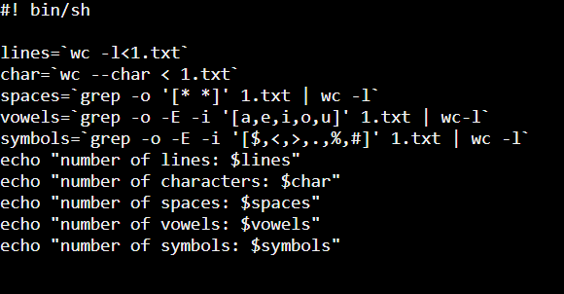

**Output:**

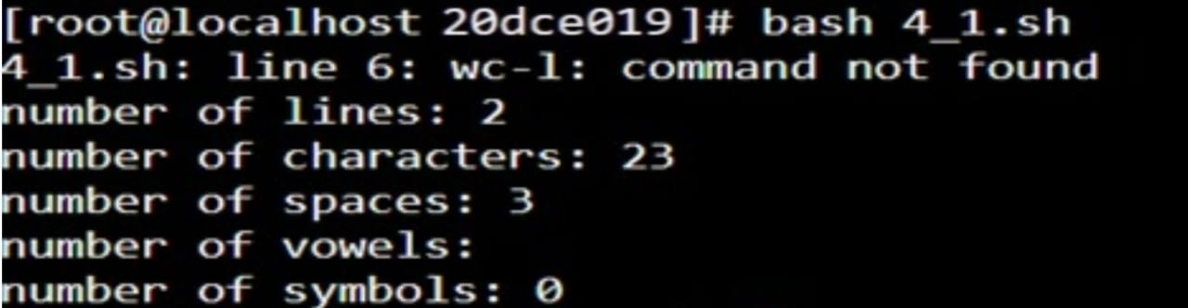

**Aim:**

**2. Write a shell script which will take a file name from the user and finds that whether the fileis there or not in a current working directory and displays the appropriate message.**

**Program:**

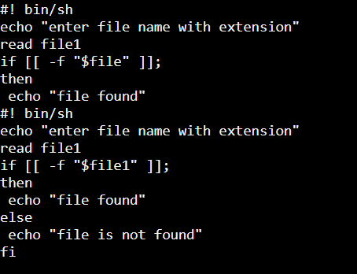

**Output:**

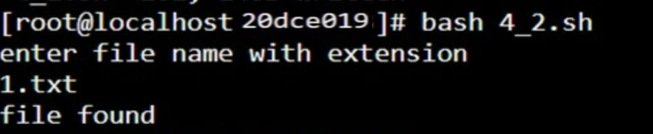

**Aim:**

**3.Write a shell script which compares two files given by the user and if both files are same then delete the second one, if not then merge the two files in a new file.**

**Program:**

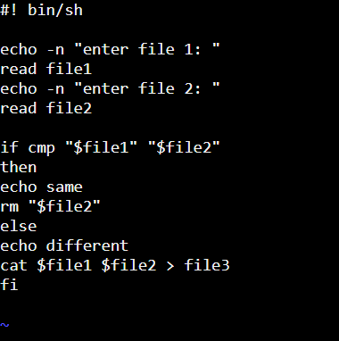

**Output:**

